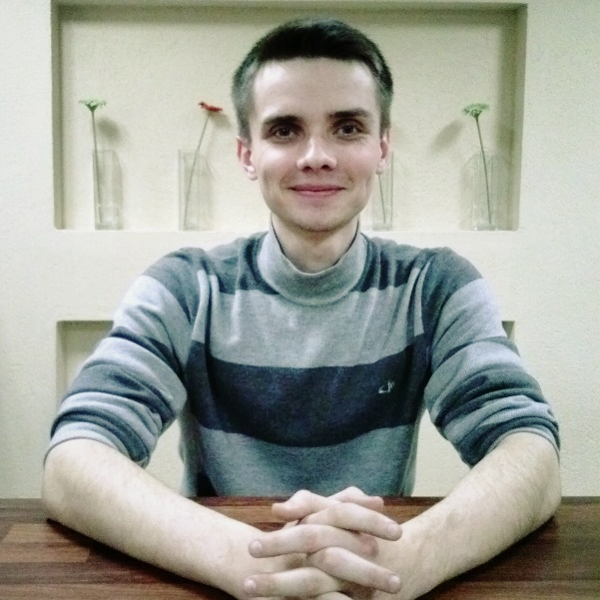
Resume
PERSONAL INFORMATION

Artem Y. Bashlykov
Stroitel,
Belgorod region, Russia
Phone: +79205757916
+79065676637
Skype: artem.y.bashlykov
Email: a_bashlykov@inbox.ru
Date of Birth: 01.01.1993
Marital Status: single
Nationality: Russian

OBJECTIVE

Obtain employment in the field of translation, public relations, or teaching that will allow me to work with people and \ or take advantage of my knowledge of English and German.

EDUCATION

Bachelor of Arts of Makiyivka Institute of Economics and Humanities
2010 – 2014
Currently I am on my fifth year at the institute and preparing to graduate as Master of Arts.

WORK EXPERIENCE

01.08.14 – 10.02.15
Headteacher at “EnglishDom” (http://www.englishdom.com/)
- Assistance to clients (consulting regarding school services and policies)
- Providing my team of teachers with appropriate workload
- Selection of teachers according to students’ needs and arrangement of trial lessons
- Settling of current issues regarding payments, rescheduling and cancellation of classes
- Supervising of learning\teaching process
- Students’ progress control (regular meetings with teachers on skype and with parents of our students if needed)
- Organization of discussion clubs for coworkers

Steward during the Euro 2012 championship matches
June - 2012 OOO “Donbass Arena”
Duties:
- Assistance to the spectators at the stadium
- Security control
- Stadium access control
- First aid rendering

SKILLS

- English – advanced (fluent speech, writing, reading)
- German – Conversational Level
- French – Elementary Level
- Proficient with computer programs such as Microsoft Word, Excel, PowerPoint, Photoshop, Corel

HOBBIES

- Sport (Ping-Pong, jogging)
- NLP (Neuro-Linguistic Programming)
- Drawing

